Assignment 3:

Problem 1(15)

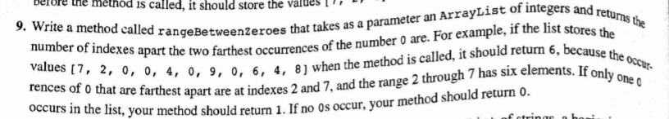

Problem 2(15)



Problem 3(15)



Problem 4(15)

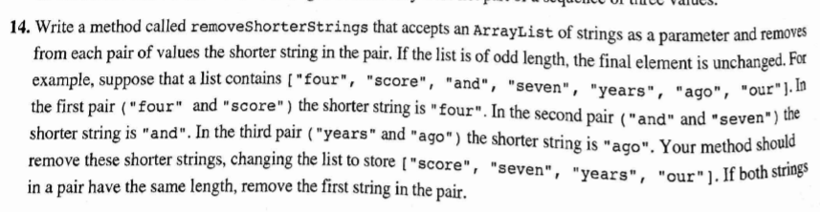

Problem 5(20)



Problem 6(20)

